***SCHEMATIC OF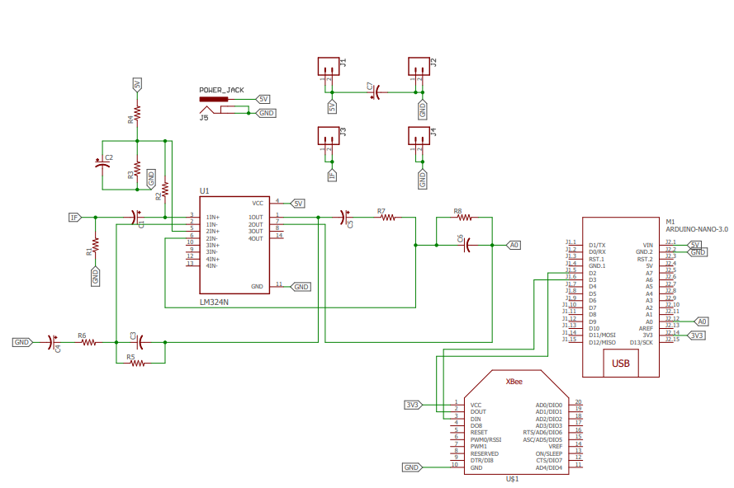 TRANSMITTER:***

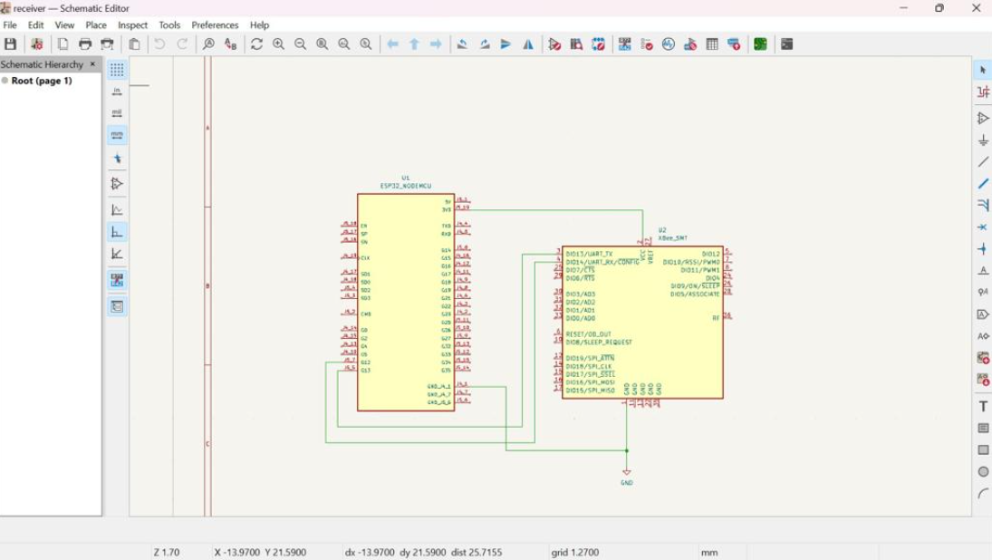

***SCHEMATIC OF RECEIVER:***

***PCB LAYOUT OF TRANSMITTER:***

